**Easiest Pizza Dough**

* 3 1/2 cups all purpose flour (original recipe had 1 3/4 cups white flour and 1 1/2 cups whole wheat flour)
* 1/4 cup olive oil (original recipe had 2 tbsp oil)
* 1 1/3 cup warm water
* 1 packet yeast (1/4th oz)
* 2 tsp sea salt

1. In a mixing bowl, combine the warm water and yeast.
2. Stir in the salt and flour and mix on medium high speed on your KitchenAid for 5 minutes.
3. While the mixer is going, drizzle in the olive oil.
4. When the dough is soft and elastic, take out of the bowl, rub with olive oil and then place back in the bowl, cover with a dish towel and let rise for one hour.
5. After the dough has doubled in size, cut in half to make two large pizza doughs or make mini doughs. You could also do what I like to do and freeze the dough in a plastic baggie for another time!
6. When you are ready for your pizza, roll out the dough, cover with your toppings and bake at 425 for 10-15 minutes.

**You could also make this dough without an electric mixer…..just knead by hand for about 8 minutes and then follow above steps! I’ve made it by hand many, many times and it always comes out right.

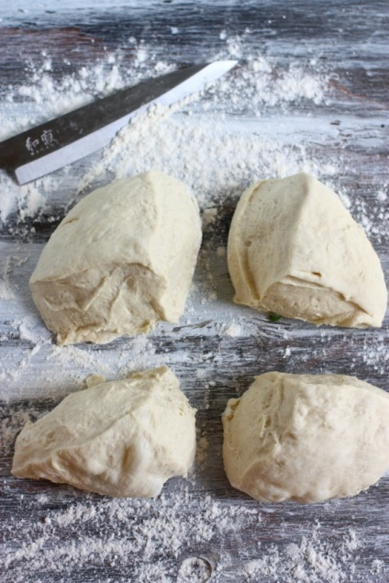

**Classic Margherita Pizza**

Ingredients

* 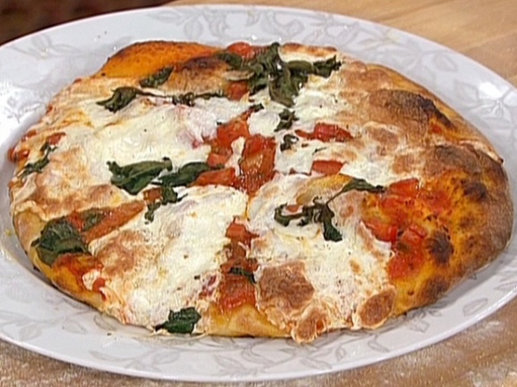Pizza dough, homemade or store-bought
* All-purpose flour, for dusting
* 3 cup Tomato Sauce
* 1/4 cup chopped tomatoes
* 1 teaspoon dried oregano
* Fresh basil leaves
* Fresh mozzarella cheese, sliced into thin rounds

Directions

1. Preheat the oven to 500 degrees F.
2. Stretch dough by gently pulling each side evenly. If needed, use a rolling pin to roll out the dough on a floured surface into approximately an 8 to 10-inch round and 1/4-inch thick.
3. Place dough on greased pizza pan.
4. Pre bake dough in 500 degree oven for 3-5 minutes.
5. Remove dough from oven, and let cool 2-4 minutes.
6. Ladle the sauce onto the dough and spread it over top, leaving about a 1-inch border around the edge.
7. Top with the tomatoes, oregano, and mozzarella rounds.
8. Place pan back in oven, bake until crust is golden brown, and cheese has melted.
9. Remove from oven.
10. Top with strips of fresh basil.
11. Cut into wedges, and serve immediately! Enjoy! ☺